|  |
| --- |
| http://www.littleeye.co    Power Report  C:\Documents and Settings\SAHAY\Desktop\untitled.bmp |
|  |

# NowFloat is a social app and hence it is quite internet data centric. As expected its power consumption is dependent mostly on its wifi usage and processing of images and location data of its user community. The power consumption can be considered average at best. The usage of CPU and network is fairly restrained but the amount of information it has to process (location, images, messages, deals, ratings, etc..) doesn’t allow it to be nimble as far as power consumption goes.

# The test was run on Nexus one device. Here is a snapshot of the power consumption graph for this app, when it was run on a Nexus One.

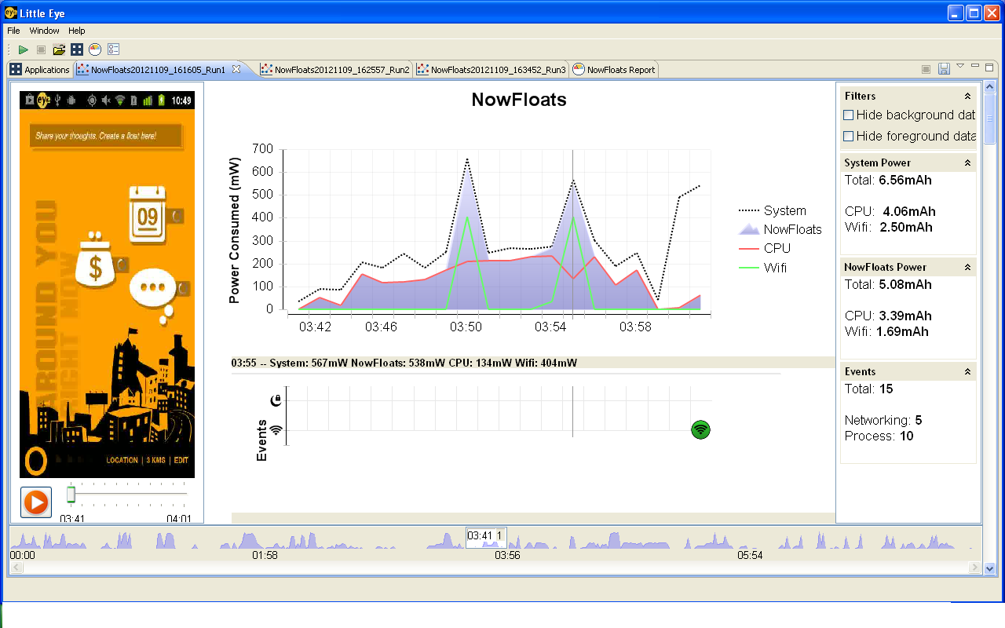

# **Benchmark numbers**

The MP10 report for ‘NowFloats’ is average in its category. According to the tests (and considering only CPU and Wifi usage into account), the app will on an average drain 10% of the battery (of a standard 1400mah capacity) in ~4:45 hours.

