|  |
| --- |
| http://www.littleeye.co    Power Report for  Paperboy  C:\Documents and Settings\SAHAY\Desktop\Paperboy_report.bmp |
|  |

# Power Analysis

# Paperboy is a news aggregator that uses sources approved by the user to get relevant articles. As a news aggregator, the network usage is critical to its functioning and is expected to be the most power consuming component. But the network optimization for this app is quite good. The app makes a very good use of caching to minimize its network usage and has quite a low power footprint for the network component. The article preview feature also encourages the user to be judicious with the use of network, helping in low power usage.

# Not being computation intensive, the CPU power consumption is also quite low. The app is a foreground app and thus as expected it quits all activity and has a very low power consumption when it is pushed to the background.

# The biggest pain point from a power perspective was the color scheme of the articles. The use of white background for the articles causes higher power drain than any other color scheme would have (eg. Black background and white text).

# The Test was carried out on Nexus One. The power test was based on **CPU**, **Wifi** and **Display** components.

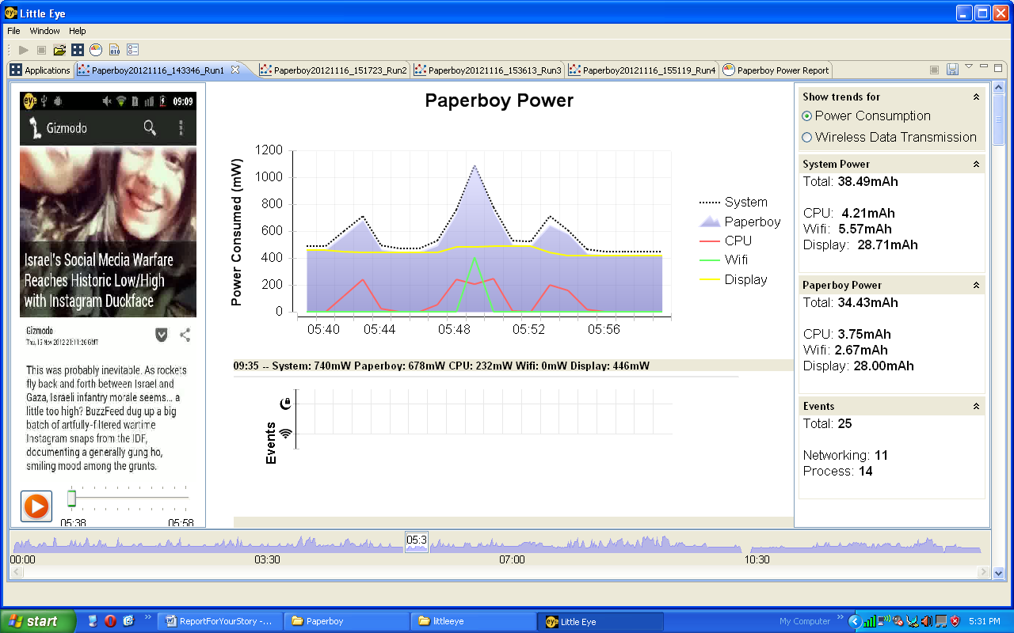

# **Benchmark numbers**

The MP10 report for ‘Paperboy’- According to the tests (and considering CPU and Wifi and Display usage into account), the app will on an average drain 10% of the battery (of a standard 1400mah capacity) in ~46 mins in foreground.

Note that battery drain % is not linear and so the above does not translate directly to ~8hrs for a full charge and most likely would be about 6-7 hrs!

